表单回复图表。题目：Q2. Please rate the extent to which each of the following challenges has affected your job search. 

(A score of 1 indicates ‘not at all challenging’, while a score of 5 indicates ‘extremely  challenging’)。回复数目：。

In this survey chart, participants were asked to rate how challenging they found various aspects of the job search process on a scale from 1 ("not at all challenging") to 5 ("extremely challenging"). The results show that the most significant challenges lie in "insufficient interview preparation or guidance," "concerns about transparency or potential scams," and "uncertainty about visa and work permit procedures." Notably, for the first two challenges, the majority of respondents rated them as either 4 or 5, indicating that a large portion of job seekers face serious uncertainty and lack of support. Additionally, issues such as “lack of clear job information” and “no response after submitting applications” were also rated as major obstacles, highlighting a widespread breakdown in communication between employers and job seekers.

From these patterns, we can identify a broader phenomenon: job seekers in the Middle East often face a lack of clarity, delayed or absent feedback, and a general sense of mistrust in the recruitment process. This reflects a structural gap in the transparency and efficiency of hiring systems across the region. Contributing factors may include language and cultural differences, complex immigration policies, and a lack of digital infrastructure or standardized hiring practices. The concern over scams and lack of transparency also suggests that many job seekers are cautious or skeptical about the legitimacy of online recruitment channels.

This phenomenon offers key insights for our HR tech company that provides AI-powered recruitment tools. It is clear that AI can and should do more than automate resume screening or job matching—it should act as a bridge of trust and support for candidates. For instance, we can develop an automated feedback and status tracking system to reduce the stress caused by application silence; introduce an AI interview coaching assistant that prepares candidates culturally and professionally; and build an AI-driven recruitment transparency certification system, potentially integrated with blockchain technology, to counter scam fears and build trust. By positioning AI as an empathetic and empowering companion in the job search journey, we can gain a strategic edge in emerging markets like the Middle East and provide real value to both job seekers and employers.

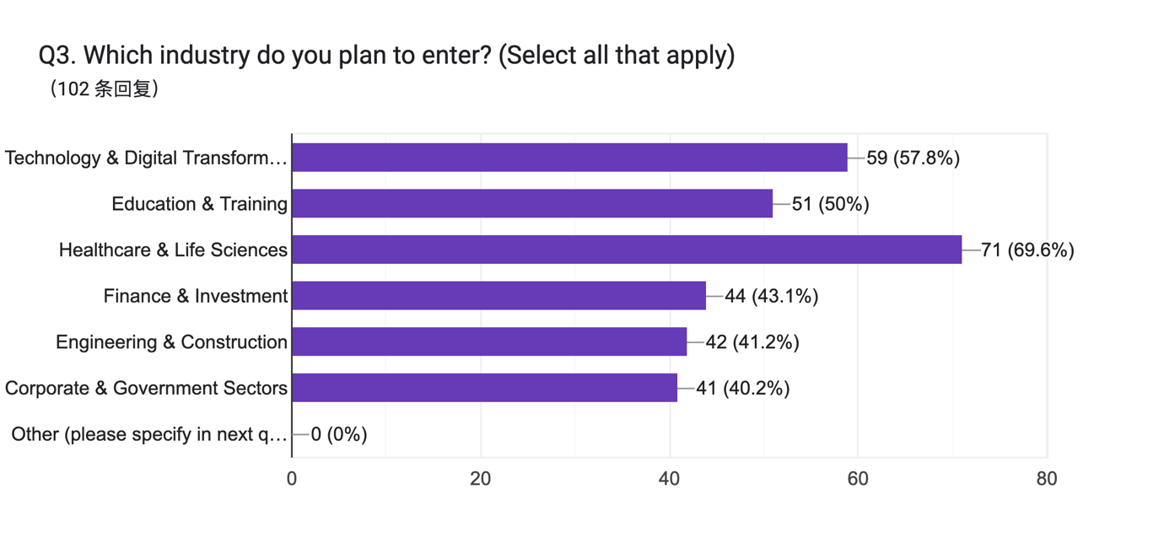

This chart reflects the industries participants plan to enter. The most popular choices were Healthcare & Life Sciences (69.6%), followed by Technology & Digital Transformation (57.8%) and Education & Training (50%). Other industries like Finance, Engineering, and Government sectors each attracted around 40% of respondents.

This suggests that young job seekers in the Middle East favor technology-driven and service-oriented sectors. High interest in healthcare and education likely reflects regional priorities such as population growth, healthcare expansion, and educational reform.

For our HR tech company, this points to a need for industry-specific AI solutions, particularly in healthcare, education, and tech. Tailored job-matching algorithms, interview prep tools, and clearer job expectation modeling can enhance placement success in these high-demand fields.

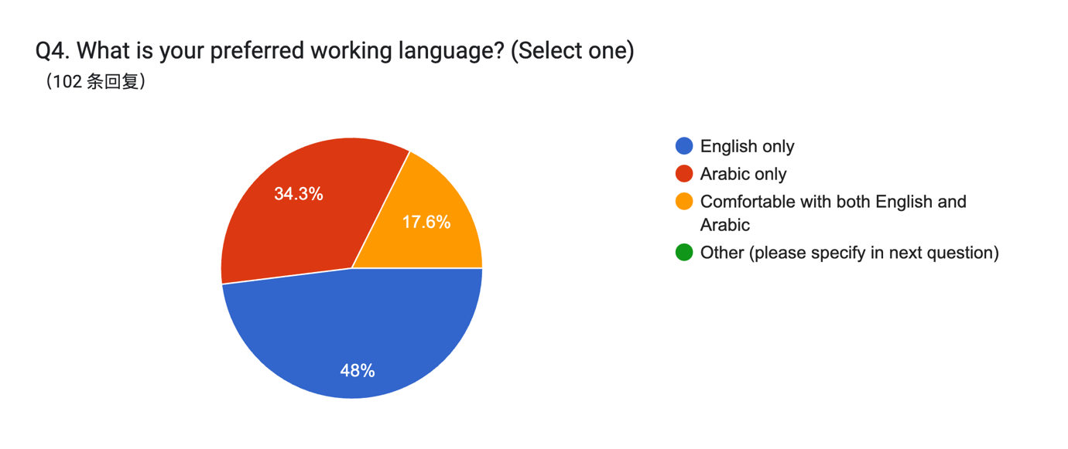

The pie chart illustrates the preferred working languages of 102 respondents. Nearly half (48%) selected English only, followed by Arabic only at 34.3%. Meanwhile, 17.6% indicated they are comfortable with both English and Arabic, and no participants chose “Other.” This suggests English is slightly more dominant, but Arabic still holds significant importance.

The data reflects a bilingual environment in the Middle East, where both English and Arabic are essential for professional communication. However, the fact that nearly one in two respondents prefer English-only indicates a growing international or corporate influence, especially in sectors like tech, finance, and healthcare.

For our HR AI tools, this highlights the need for language adaptability. Interfaces, job descriptions, and automated feedback should ideally be offered in both English and Arabic, with seamless switching. Furthermore, AI interview preparation tools should accommodate both languages to ensure inclusivity and a smoother user experience for all candidates.

表单回复图表。题目：Q5. Please rate your level of concern for each of the following aspects of working in Saudi Arabia.

(1 means ‘not concerned at all’, 5 means ‘extremely concerned’)。回复数目：。

The chart reveals the level of concern respondents have about various aspects of working in Saudi Arabia. Across all listed items, the most frequent responses fall under “4 – Very concerned” and “5 – Extremely concerned.” Top areas of concern include language barriers, salary and benefits not meeting expectations, and employer reliability (e.g., delayed salary or unclear contracts), all of which received the highest number of “very” and “extremely concerned” ratings. Other issues such as legal protection, workload, and cultural adaptation also drew significant concern levels, although slightly lower.

This data highlights a general apprehension among potential employees about job security, communication challenges, and working conditions in Saudi Arabia. The high concern over language and legal clarity suggests that many job seekers feel vulnerable due to regulatory uncertainty and a lack of transparent communication in employment processes. This aligns with wider regional concerns about labor rights, expatriate protections, and work-life balance.

For AI-driven HR platforms targeting the Middle East, particularly Saudi Arabia, these findings suggest a need to address trust, transparency, and language support. Features like AI contract explainers, salary benchmarking tools, and bilingual onboarding assistants can help alleviate fears and enhance user confidence. Emphasizing safety and fairness through clearly communicated, AI-supported HR processes will be key to attracting and retaining talent in this region.

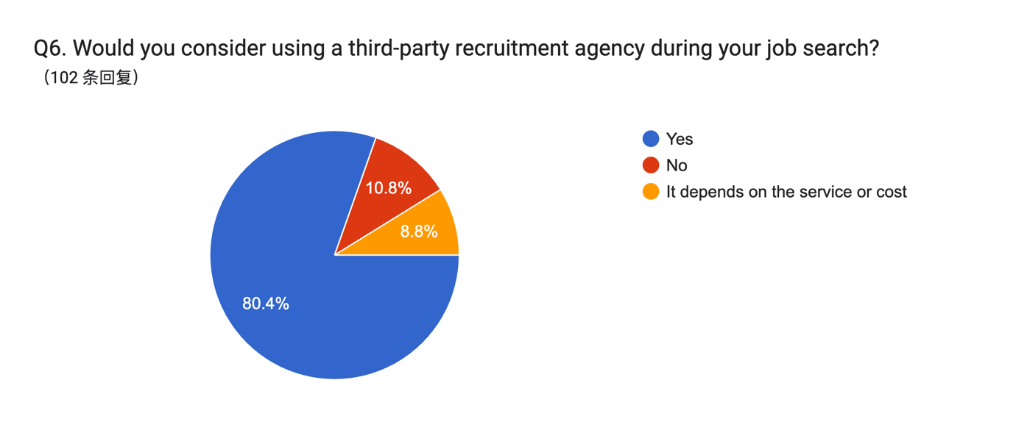

The pie chart shows that a large majority of respondents (80.4%) are open to using a third-party recruitment agency during their job search. Only 10.8% said no, while 8.8% said it depends on the service or cost.

This indicates a strong willingness to seek external help in the job search process, especially if the agency offers value-added services. It also suggests that candidates may be experiencing challenges or lack of clarity that they believe third-party experts can help resolve.

For recruitment agencies and HR tech firms, this is a positive sign—there’s clear demand. Offering affordable, transparent, and high-quality AI-enhanced services (like resume matching, application tracking, or interview coaching) could attract a broad user base in this region.

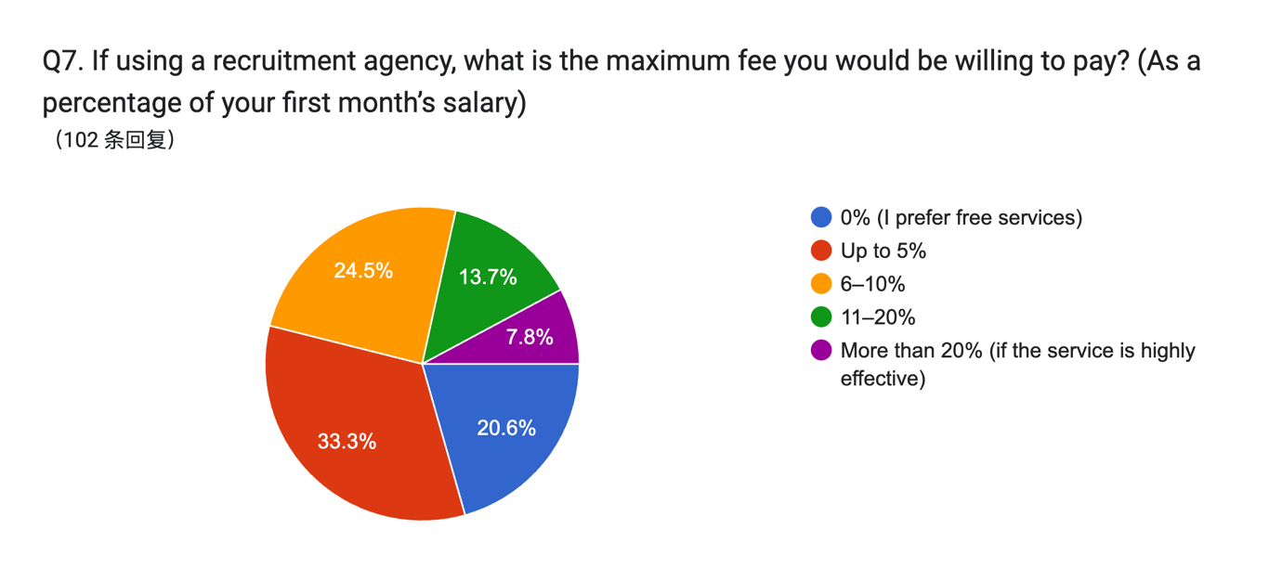

The chart shows respondents’ willingness to pay a recruitment agency fee as a percentage of their first month’s salary. 33.3% are willing to pay up to 5%, and 24.5% are open to 6–10%. Meanwhile, 20.6% prefer free services, and 13.7% would accept a fee of 11–20%. Only 7.8% are willing to pay more than 20% for a highly effective service.

Most job seekers are price-sensitive, but not entirely unwilling to pay. Over 70% of respondents are willing to pay some fee, suggesting they value support—as long as the pricing is reasonable and the service effective.

Agencies should consider offering tiered pricing models or freemium AI recruitment tools, where core services are free or low-cost, and advanced support (e.g., personalized matching, mock interviews) is paid. Communicating the value and success rate of premium services will be key to justifying higher fees.

表单回复图表。题目：jiuQ8. Please rate the importance of each of the following aspects of a recruitment agency

(A score of 1 means ‘not at all important’ and a score of 5 means ‘extremely important’）。回复数目：。

The chart illustrates how respondents rated the importance of various services provided by recruitment agencies. Overall, most participants considered each service either "very important" or "extremely important," indicating high expectations from agencies. Among the most valued services were legal visa support and compliance, fast job matching, transparent pricing, and direct connections with Saudi employers. Post-placement support, such as assistance with housing or legal issues, also received significant emphasis. Very few respondents rated any service as unimportant, showing that job seekers are looking for well-rounded, reliable support throughout their job search and employment journey.

This data reveals that candidates are not just seeking help with job placement, but rather a comprehensive solution that supports them before, during, and after employment. The high importance placed on legal compliance and post-placement services suggests a concern for stability and integration in a foreign work environment. At the same time, strong interest in fast job matching and employer connections points to a desire for efficiency and trusted access to real opportunities.

For recruitment agencies, this underscores the need to deliver end-to-end services that go beyond basic job referrals. Integrating AI solutions that enhance transparency, streamline compliance checks, and facilitate ongoing candidate support could significantly increase user trust and satisfaction. In regions like Saudi Arabia, where legal and cultural adaptation is a major concern, agencies that can offer reliable, tech-enabled guidance will likely be preferred partners in the job search process.

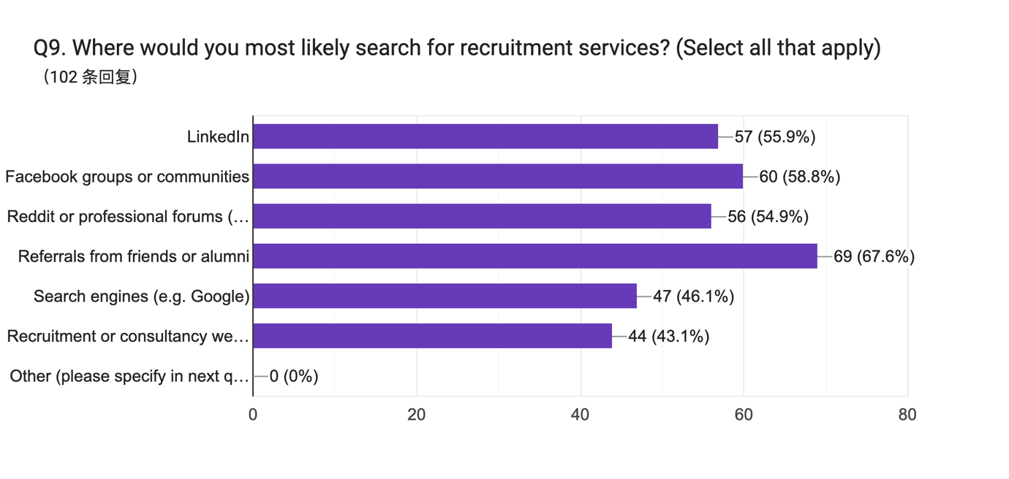

This chart presents the preferred channels where respondents are most likely to search for recruitment services. The most popular choice is referrals from friends or alumni, selected by 67.6% of participants, highlighting the importance of personal networks and trust in job-seeking behavior. Close behind are Facebook groups or communities (58.8%), LinkedIn (55.9%), and Reddit or other professional forums (54.9%), indicating a strong preference for community-based and interactive platforms where users can share experiences and recommendations.

Search engines like Google (46.1%) and official recruitment or consultancy websites (43.1%) were also mentioned, though less frequently, suggesting that while candidates do conduct independent searches, they may be more drawn to sources with perceived authenticity and personal insight.

This data reflects a tendency among job seekers—particularly in regions like the Middle East—to rely on informal, community-driven channels over formal institutional websites. For recruitment agencies, this points to the need for an active presence not just on LinkedIn, but also on social platforms and forums, as well as fostering peer referral programs. Building trust and visibility within these ecosystems may be just as crucial as maintaining a professional website.

表单回复图表。题目：Q10. Have you used any of the following AI-powered job search tools? (Select all that apply)
。回复数目：（102 条回复）。

This chart shows respondents' usage of various AI-powered job search tools. The most commonly used tools include AI-based CV/resume builders, AI-generated cover letters or applications, and AI chatbots for job search Q&A, each used by 55.9% of participants. AI interview coaches and job-matching platforms followed at 48% and 46.1%, respectively. Notably, 44.1% of respondents indicated they have not used any AI-powered job tools, suggesting that while adoption is significant, it is far from universal.

The data reveals a growing but still developing familiarity with AI in recruitment. The fact that more than half of the respondents have used AI for resumes, applications, and chatbots shows strong interest in tools that simplify and automate key parts of the job search. However, the relatively high percentage of those who have never used any of these tools signals an opportunity gap—many candidates may lack access, awareness, or confidence in using AI-powered platforms.

HR tech companies should continue investing in user-friendly, accessible AI tools that focus on the most adopted areas—such as resume optimization, application writing, and real-time support. At the same time, there is a need for awareness-building and user education, especially in emerging markets like the Middle East. Demonstrating the effectiveness, ease of use, and trustworthiness of these tools could help convert the remaining 44.1% into users. Clear onboarding processes and multilingual interfaces could further improve adoption rates.

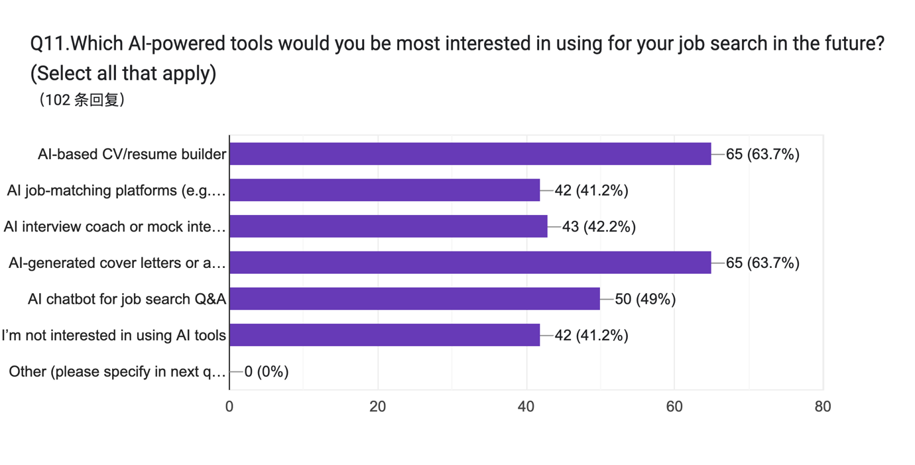

The chart shows respondents’ interest in using AI-powered tools for future job searches. The two most popular choices are AI-based CV/resume builders and AI-generated cover letters or applications, each selected by 63.7% of participants. This is followed by AI chatbots for job search Q&A at 49%, and both AI job-matching platforms and AI interview coaches at around 41%. Notably, 41.2% of respondents also indicated they are not interested in using AI tools, suggesting a split in attitudes toward AI adoption.

There is a clear demand for AI tools that assist with application materials—such as resumes and cover letters—likely because these are high-effort, high-stakes components of the job search process. However, the fact that over 40% of respondents are either uninterested or uncertain about AI adoption points to lingering trust issues, lack of familiarity, or skepticism about the effectiveness of such tools. This shows that while some candidates are eager for AI support, others may require more reassurance or education.

For HR tech companies, the opportunity lies in doubling down on the most desired features—resume and cover letter generation tools—while also addressing concerns from less enthusiastic users. This could be achieved by offering transparent, explainable AI, demo versions, or success case studies to build confidence. Additionally, since nearly half of respondents are still hesitant, user onboarding, multilingual support, and trust-building messaging will be essential to expanding adoption in diverse markets like the Middle East.

表单回复图表。题目：Q12. Please rate your level of agreement with each of the following statements regarding the use of AI throughout the recruitment process
(A score of 1 means ‘completely disagree’ and a score of 5 means ‘completely agree’ )  。回复数目：。

The chart shows respondents’ interest in using AI-powered tools for future job searches. The two most popular choices are AI-based CV/resume builders and AI-generated cover letters or applications, each selected by 63.7% of participants. This is followed by AI chatbots for job search Q&A at 49%, and both AI job-matching platforms and AI interview coaches at around 41%. Notably, 41.2% of respondents also indicated they are not interested in using AI tools, suggesting a split in attitudes toward AI adoption.

There is a clear demand for AI tools that assist with application materials—such as resumes and cover letters—likely because these are high-effort, high-stakes components of the job search process. However, the fact that over 40% of respondents are either uninterested or uncertain about AI adoption points to lingering trust issues, lack of familiarity, or skepticism about the effectiveness of such tools. This shows that while some candidates are eager for AI support, others may require more reassurance or education.

For HR tech companies, the opportunity lies in doubling down on the most desired features—resume and cover letter generation tools—while also addressing concerns from less enthusiastic users. This could be achieved by offering transparent, explainable AI, demo versions, or success case studies to build confidence. Additionally, since nearly half of respondents are still hesitant, user onboarding, multilingual support, and trust-building messaging will be essential to expanding adoption in diverse markets like the Middle East.

表单回复图表。题目：Q13. If an AI platform could signiﬁcantly improve your chances of ﬁnding a great job, would you be willing to… (Select one)
。回复数目：（102 条回复）。

The pie chart shows how respondents would respond if an AI platform could significantly improve their chances of finding a great job. The most common choice (22.5%) was a willingness to take more AI-based assessments or mock interviews, followed closely by not using such a platform (21.6%). Other responses were fairly evenly distributed: 19.6% would only use it if it’s free, 18.6% would share more personal data for better job matches, and 17.6% would pay a fee for premium features.

This data reveals a divided attitude toward AI recruitment platforms. While many respondents are open to deeper engagement—especially in the form of mock interviews and skill assessments—there is still a notable portion who are hesitant or unwilling to participate, especially if the service involves cost or personal data sharing. The high number of users who would only use the platform if it’s free or wouldn’t use it at all suggests concerns around value, affordability, and privacy.

To maximize adoption, AI recruitment platforms should prioritize building value and trust. Offering free core features (such as assessments) can draw in skeptical users, while providing optional premium upgrades could appeal to more committed job seekers. Clear privacy policies and transparent data usage will also be essential to address resistance around personal data sharing. Most importantly, platforms should focus on delivering tangible, proven benefits—like better job matches or interview prep results—to convert hesitant users into loyal ones.

BASIC INFORMATION

表单回复图表。题目：Q14. Demographic information (optional but appreciated)

a. Age group 
。回复数目：（102 条回复）。

表单回复图表。题目：b. Gender 
。回复数目：（102 条回复）。表单回复图表。题目：c.  Which category best characterises your experience in Saudi Arabia? (If you have had multiple experiences, please choose the one you consider to be the most significant, the longest-lasting, or the one that has had the greatest impact on you)
。回复数目：（102 条回复）。

The demographic data shows that the majority of respondents (54.9%) fall within the 25–34 age group, followed by 22.5% aged 35–44. The youngest group (18–24) makes up 11.8%, while only 10.8% are aged 45 or older, indicating a predominantly young to mid-career audience. In terms of gender, the sample is almost evenly split, with 51% identifying as female and 49% as male, suggesting balanced representation. Regarding experience in Saudi Arabia, nearly half (46.1%) reported being there primarily for studying, followed by 32.4% for work, and 14.7% for general living. Only a small portion (6.9%) indicated no relevant experience in Saudi Arabia, confirming that most respondents have first-hand familiarity with the region.